Session 1

1.
install MySQL Workbench on your computer, connect to the local MySQL server, and take a screenshot of the default databases shown in the Schemas panel.
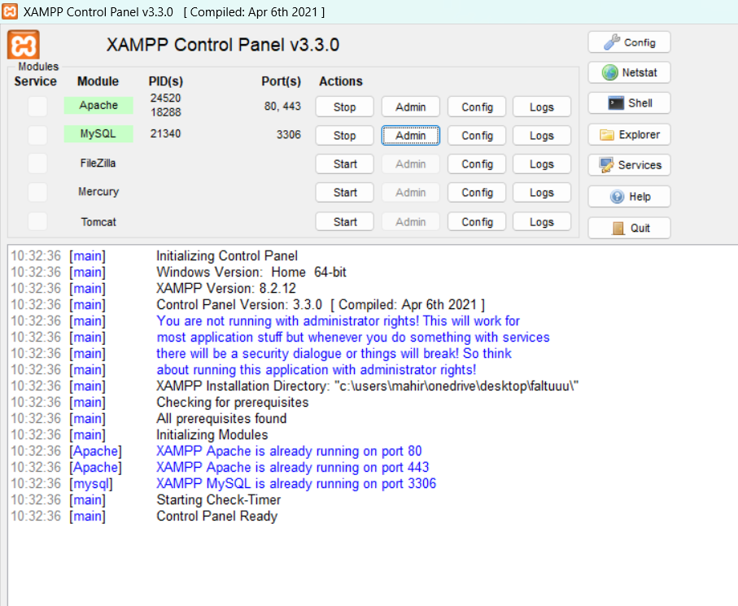
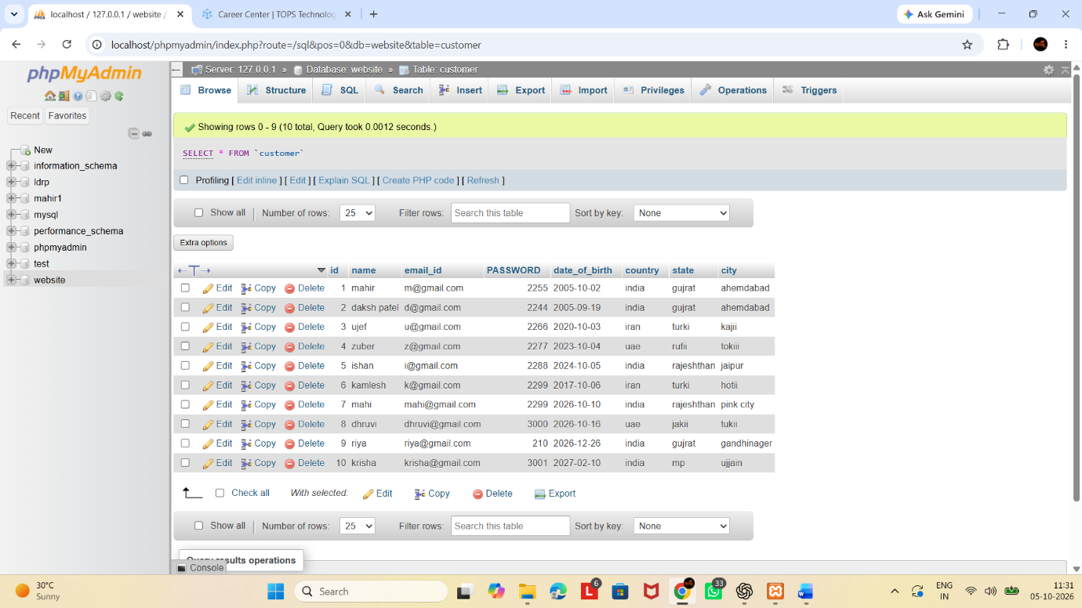
2.
Create a new database called InstaClone in MySQL Workbench, then create a table named Users with columns: user_id (INT, primary key), username (VARCHAR), email (VARCHAR), and followers_count (INT).
CREATE DATABASE InstaClone;

CREATE TABLE Users (
user_id INT PRIMARY KEY auto_increment,
username VARCHAR(255),
email VARCHAR(255),
followers_count INT
);

3.
Insert 3 sample users into the Users table you created, using realistic Instagram-style usernames and follower counts.
INSERT INTO Users (user_id, username, email, followers_count)
VALUES
(1, 'maya.travels', 'maya.travels@example.com', 12400),
(2, 'theo.cooks', 'theo.cooks@example.com', 8350),
(3, 'luna.frames', 'luna.frames@example.com', 27600);
4.
Create another table in the InstaClone database called Posts with columns: post_id (INT, primary key), user_id (INT), caption (VARCHAR), and post_date (DATE). Add a foreign key from Posts.user_id to Users.user_id to establish a relationship.
CREATE TABLE Posts (
post_id INT PRIMARY KEY,
user_id INT(2),
caption VARCHAR(255),
post_date DATE,
FOREIGN KEY (user_id) REFERENCES Users(user_id)
);
5.
Write a short comparison (3-4 lines each) of MySQL, PostgreSQL, Oracle, and SQLite, focusing on where each one is commonly used (for example: web apps, mobile apps, enterprise systems, etc.).
- MySQL: Common in web applications and content-management systems. Often used for sites and services that need a widely supported relational database.
- PostgreSQL: Popular for web apps, analytics, and systems with complex queries or data types. Often chosen when standards support and extensibility matter.
- Oracle Database: Common in large enterprises, banks, and government systems. It supports demanding workloads and extensive enterprise management needs.
- SQLite: Common in mobile apps, desktop software, and embedded devices. It stores a database in a single local file, so it works well without a separate server.

